Requirements Engineering:
- Rob updates Requirements Specifications document found in sprint 3
  - Included functional requirement for support for at least 2 different databases
  - Included features for multiple databases being supported by the system.
- Team may find it useful to implement a local API using docker for ORS to overcome the constraints set up from the free subscription.

Design Specification:
- Rob expanded on requirement specification into FreshTime plan which is a running plan of the tasks required in order to fulfill the requirement specification.
- Team chose to implement a UI for this project will be using javaFX and scene builder because we have lots of code we can reuse..
- Kiernan decided to use Docker over Node JS since there is more documentation for deploying using Docker.

Architectural Design:
- Rob updated conceptual view diagram for FreshTime
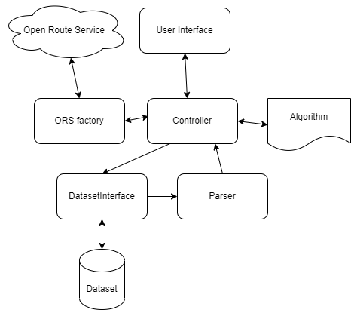

Design Implementation
- Brian curated a dataset of 1000 points + 100 restaurants in a dataset
- Kiernan researched OpenMapService which is a service that allows auto formatting of CSV for database
- Rob created a FreshTime project in github and implemented the reused software to the specifications found in the software reuse document.
- Kiernan started to implement deploying a local web application for ORS using Docker.

Advanced SWE Topics:
- Rob created a software reuse document outlining the classes to be reused from the last project.
- Rob created a project plan that outlines the tasks required to fulfill the application functions found in the specification document.

